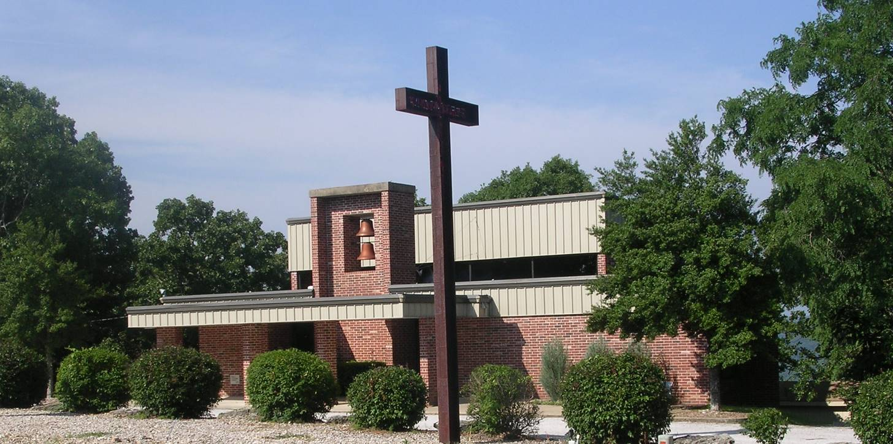





Grace Lutheran

179 Holiday Island Drive
Holiday Island, AR 72631
479-253-9040
www.gracelutheranhi.com

April 2024
We at Grace Lutheran Church are called to reach, teach and be the people of God, as stewards of the Word and gifts of God.

FROM THE
PASTOR’S DESK

Dear Grace Family,
As we enter the month of April we enter Eastertide, that is, the Season of Easter. As Christmas doesn’t end with the arrival of Christmas Day but extends to January 6th, Easter doesn’t end with the Sunday of Easter but lasts for 6 more Sundays. It is interrupted on the 40th day by the Feast of the Ascension, and then the 7th Sunday of Easter followed by Pentecost Sunday 10 days after the Feast of the Ascension.
Eastertide has many traditions in celebration of the Season, many of which have been left forgotten or collapsed into Easter Sunday and never seen again until the next Easter Sunday. One of these is the Easter Octave. The Easter Octave (also known as Easter Week contrary to the present-day confusion of Holy Week with Easter Week. It begins on Easter Sunday and concludes on the Second Sunday of Easter. Easter Week is a week of feasting as Lent, the season of fasting is over. Now there’s something to look forward to.
There are a number of Eastertide customs, many of which have disappeared from American Christianity. The flowering of the cross is one that is still celebrated by some congregations where the bare cross is decorated with flowers. Clipping the Church is an ancient custom that is traditionally held in England on Easter Monday. The word "clipping" is Anglo-Saxon in origin meaning "embrace" or "clasp". Clipping the church involves either the church congregation or local children holding hands in an inward-facing ring around the church, and can then be reversed to an outward-facing ring when a prayer for the wider world beyond the parish is said.
Eastertide was a season filled with Easter games such as the Easter Egg Hunt where, as you know, children collect as many eggs as they can in a kind of Easter Egg treasure hunt. This is the game that most are familiar with. However, there were others that could be brought back into your Easter Week celebrations. The Egg Roll is when eggs are rolled down a steep hill or pushed across the lawn with sticks. . . . .
[continued next page]

Egg Tapping is a contest for the hardest egg where the contestants tap each other’s eggs with the egg tips to see whose egg cracks first. The Egg Toss is where participants throw the eggs in an attempt to land it without breaking. Another fun Egg Toss is where participants throw raw eggs back and forth attempting to catch them without breaking. There is also the traditional Egg Dance where eggs are places on the floor and the participants dancing among the eggs while blind folded. Of course there are the Easter foods, Easter parades, Easter Lilies and many more. All to enjoy as we celebrate “Christ is Risen!”
The liturgical color for Eastertide is white. White signifies birth and resurrection of Christ as it symbolizes purity, light, glory, and joy.
With the arrival of Eastertide it is a great time for Christians to focus their faith life in regular attendance at the Divine Service, devotions, and the study of God’s Word for our lives.

See you in the
Eastertide Divine Service,
In His Service and Yours
Pastor Schultz

The following is reprinted with permission from Chad L. Bird of 1517.org Pastor Schultz
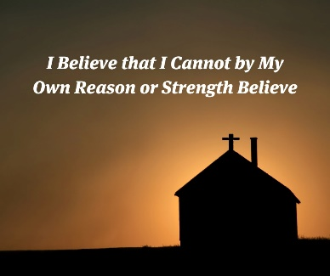

"No one can say 'Jesus is Lord' except by the Holy Spirit" (1 Cor. 12:3). That statement from Paul is behind a line in the Small Catechism which says, "I believe that I cannot by my own reason or strength believe in Jesus Christ, my Lord, or come to Him; but the Holy Spirit has called me by the Gospel...."
Now what does it mean that we cannot by our own "strength" believe? It does not mean that, were we strong enough, we would be capable of faith. It's not our weakness that prevents us from faith.
Quite the opposite. Our very "strength" keeps us from believing! Our self-confidence. Our strong attachment to thinking we can decide for or against God, as if he's an "option" for us. This kind of strength is precisely our problem.
We cannot by our own strength believe because our sinful, stubborn, blind, self-interested "strength" keeps getting in the way.
So what does God do? He kills it. He reveals its death, our death. And in that God-created weakness and death, we are called by the Gospel, enlightened with his gifts, sanctified, and kept in the true faith, as the catechism goes on to say.
He puts us in the tomb with Lazarus, as it were, so that out of the tomb of weakness and death, wrapped in our death clothes, Christ might call us by proclaiming, "Sinner, come forth!" And we do, made alive by the Word of Life himself.
Chad L Bird
Resident Scholar
1517.org

Reports from the Mission Field
Dear Grace Family,
As a means to help us be better connect to the work that goes on in the Mission Field, and the work of our LCMS Missionaries, I’ve asked the Rev. Christian Tiews permission to reprint some of his reports in our monthly newsletter. He graciously approved. This month, I submit the following. Pastor Schultz
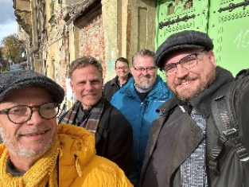

“…and what you have heard from me in the presence of many witnesses entrust to faithful men, who will be able to teach others also” (2 Tim 2:2), said the Apostle Paul to his student Timothy, encouraging the young man to teach others who in turn would instruct yet another “generation” of students. Fast forward two millennia… Back in the mid 2000s, I enrolled in the Master of Divinity program at . . . . . .

Concordia Seminary St. Louis and a decade later in the Doctor of Ministry program at Concordia Theological Seminary Fort Wayne. One decade after that, I am serving as a missionary and theological educator at Luther Academy, Riga, Latvia, a European Union-accredited online seminary, alongside my missionary colleagues Rev. Dr. David Preus, Rev. Jerry Lawson—here accompanied by LCMS Office of International Mission Executive Director Rev. Dr. Cory Rajek—and Rev. Dr. Quintin Cundiff (from L to R), as well as Rev. Dr. Samuel Bobby, and Rev. Dr. John Bombaro (the last two not pictured). What we once learned at our LCMS seminaries stateside we are now privileged to pass on to the ever-growing group of students at Luther Academy, some 30 strong—from 18 countries. This past week I concluded Part Two of “Overview of the Bible,” the first semester having been taught by Dr. Bombaro. I immensely enjoyed instructing our students who live in Albania, Finland, Germany, Norway, Turkey and even Ukraine, and hail from those countries but also from Iran and Russia. I was particularly moved by the two students whose home countries are at war with one another (with both students agreeing that Russia is the aggressor). Our common language is English, but the language skills of the students vary, as does their familiarity with Lutheran doctrine. But one thing is certain: all of them aspire to become Lutheran pastors or deaconesses. May the Lord bless them all as they grow in their understanding of Lutheran Christianity, which they will one day—God willing—pass down to their own parishioners and perhaps even a new generation of church leaders!

Rev. Christian C. Tiews
Hamburg, Germany



March
Birthdays
Dean Bennett 7
Karen Quinly 8
Sherry Steichen 13
Bruce Bleser 18
Linda Riggin 30
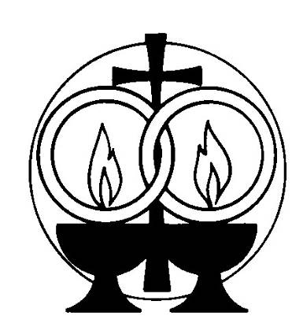

March

Anniversaries
None listed

Men’s Fellowship
Meeting on Saturday mornings vs Monday mornings will work for our congregation members who still work. The group prefers to meet at the church and the April meeting will be the 13th. Josh and Randy will be the cooks.
All our men are invited to join us for fellowship at 8:30am and meeting are program at 9:00am.

Palm Sunday

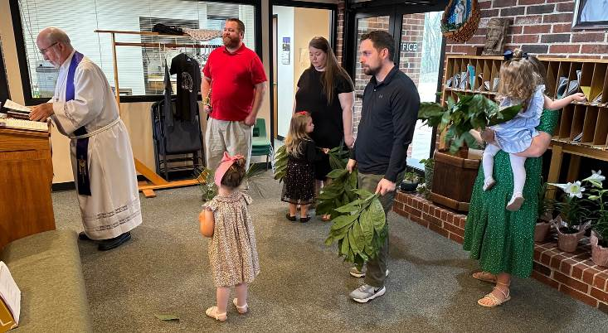
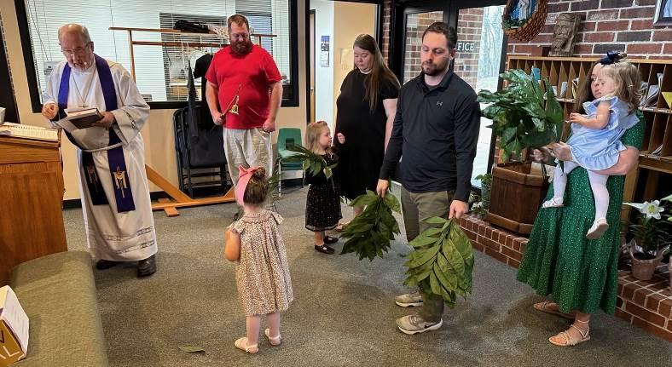

Women's Guild

ATTENDEES: S. Garrett, V. Garrett, A. Garrett, T. Herman, R. Wegener, B. Haydon, J. Bleser, J. Smith, S. Fenske, B. Herring, G. Cates, C. Bonner
OPENING PRAYER by Stephanie Garrett
President Stephanie Garrett thanked Jane Smith and Sherry Fenske for providing refreshments.
DEVOTION by Vicki Garrett, Thinking on These Things - by Heidi Goehmann, Philippians 4:8

REPORTS
Minutes from February were printed in March's Newsletter after proofed.

UNFINISHED BUSINESS
Mite Box - Box will be located near the last pew for best attention - Ongoing.
Cookbook - Barbara Herring presented the drafted cookbook with each subject sectioned. Cookbook will offer additional room for more recipes. Final printing is to be determined.
Veil for Alter - Barbara Herring explained the difference in fabrics and is waiting to hear from the representative. Veil should be 36" x 36". The linen veil should be ironed three times (front, back, and front including corners, and handled by the corners.) Always use a steam iron, (not a touch up steamer,) to iron the veil. Then let it lay on the ironing board until it cools. Terri Herman moved that Barbara purchase the two samples of fabrics. Jane Bleser seconded. The vote passed. She will purchase one Easy care veil and a Linen veil. We will determine which one works best for our purposes and for care and cleaning.
Spring Outing May 2nd at 9:00AM at Ozark Botanicals Garden. Ladies meeting at church 8:00AM for carpooling. Reservations made at The Mermaid Seafood Restaurant for 12:00PM, table for 20. Sherry Fenske is checking on location in Bentonville or Fayetteville.

NEW BUSINESS
Birthday/Anniversary cakes - Vicki Garrett moved for cake to be provided by the first week's signer on the Fellowship monthly chart. Barbara Herring seconded. Vote carried.
Palm Sunday Easter Egg Hunt with Grilled Hot Dogs - Pastor's Home, March 24th after church service. Side dishes will be needed and brought by members attending. Sign-up sheet in the Narthex.
Visitor Welcome Gift Bags - Preparing visitor's welcome gift bags will begin. Contents will consist of Lutheran information, candy, cup, etc.

Next Meeting Date: April 16, 2024 at 0PM
Devotion : Stephanie Garrett
Fellowship : Terri Herman and Barbara Herring
Closing Prayer: Stephanie Garrett
Adjournment - 3:40 PM



