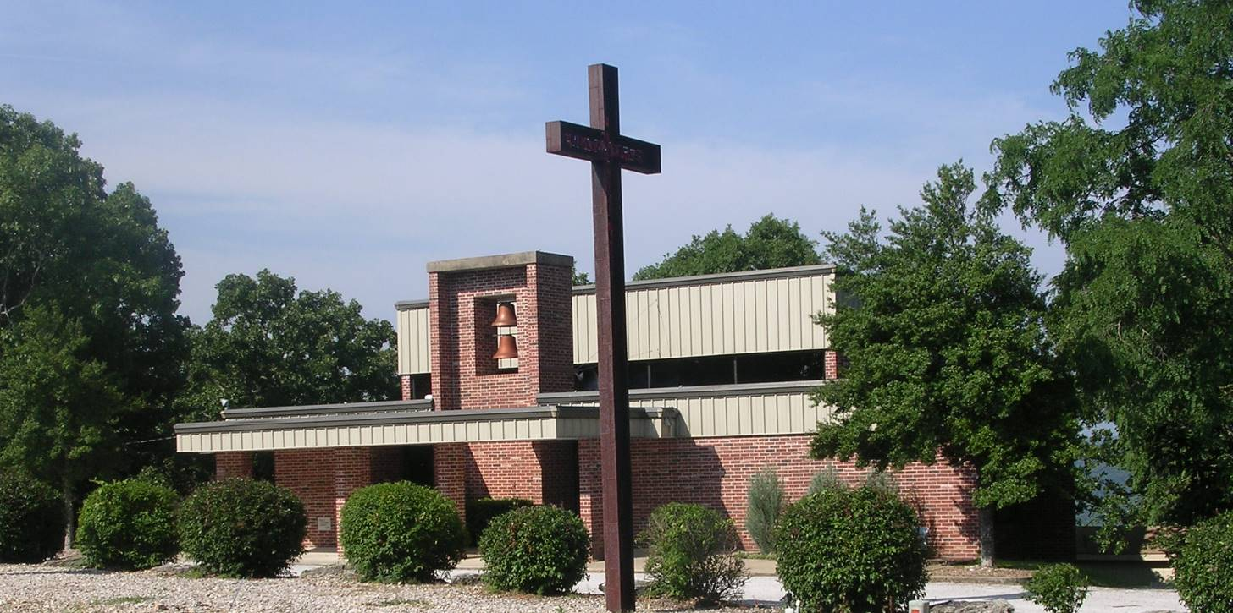

## Grace Lutheran

#### 179 Holiday Island Drive

Holiday Island, AR 72631

479-253-9040

www.gracelutheranhi.org

October 2023

We at Grace Lutheran Church are called to reach, teach and be the people of God, as stewards of the Word and gifts of God.

FROM THE

PASTOR’S DESK

With the arrival of October, the minds of Lutheran pastors turn to the remembrance of the nailing of the ninety-five theses to the Wittenberg Church door.



Have you ever heard people say, "Who needs denominations? God is too big to be squeezed into a little box. Just give me Jesus."

At first glance, this remark seems to make sense. After all, denominations are, in fact, man-made, and do appear to make "one faith, one Lord, one Baptism" (Eph 4:5) more complicated than would seem necessary.

Denominationalism can be traced back to the Reformation itself. Therefore, denominational differences can be traced back to the Reformation as well.

What all Christian denominations have in common, of course, are the three ecumenical Creeds: the Apostles', the Nicene, and the Athanasian Creed.

But, the thing is, as soon as you start digging a little bit deeper into the Christian faith, you cannot avoid making some decisions about how Scripture wants to be understood. Very soon you will come upon "forks in the road" that will demand that you go either left or right.

According to a report written by Philipp Melanchthon, Luther posted the Ninety-Five Theses at the Castle Church in Wittenberg, Germany on October 31, 1517. Some scholars have questioned the accuracy of this account, noting that no contemporaneous evidence exists for it. Others have countered that no such evidence is necessary, because this action was the customary way of advertising an event on a university campus. Church doors at the time functioned very much as bulletin boards. Still others suggest the posting may well have happened sometime in November 1517. When referring to the 95 Theses, it is nevertheless quite safe to say that they were posted on October 31, 1517, on a church door. The day of October 31 is All Hallow's Eve, and, since on the following day most people will go to church, posting his theses on this day makes a lot of sense.

*[continued next page]*

And, in fact, in February 2007, the media reported that a handwritten note by Luther's secretary Georg Rörer, found in the university library at Jena, appeared to confirm the traditional account of Luther's nailing the theses to the door.

The background to Luther's Ninety-Five Theses centers on particular disputes within the Roman Catholic Church regarding confession and absolution. Significantly, the Theses offer a view on the validity of indulgences (remissions of temporal punishment due for sins which have already been forgiven). They also view with great cynicism the practice of indulgences being sold, and thus the penance for sin representing a financial transaction rather than genuine contrition. Luther's theses argued that the sale of indulgences was a gross violation of the original intention of confession and penance, and that Christians were being falsely told that they could find absolution through the purchase of indulgences.

His Service and Yours

Pastor Schultz

# Church Words:

# Love



Love makes the world go around. We love our pets, our favorite food, good weather, our sports teams, our friends, freedom and truth — just about everything. Americans seem to love just about everything!

In the Bible, two Hebrew words are used to speak about love. The word אהב (*‘ahav* — love) means just about the same things as our word *love*. The Holy Scriptures this term means most of the time the love shown by people and very rarely is used for God’s love. The word חֶ֫סֶד (*chesed*— love, kindness, mercy, loving-kindness) is very hard, if not impossible to translate. The King James Version called it lovingkindness. It is in almost all of the expressions of God’s love in the Old Testament. The word חֶ֫סֶד and the Greek Word ἀγαπάω mean about the same thing. Yet it has a tenderness to it that includes compassion and mercy.

The Greek language of the New Testament has several words for love. φιλέω (phileo) is the love and affection between friends ἔρος  (Eros) is sexual love that is obsessed with another and is not satisfied until it gets what it wants. ἀγαπάω is a love that sacrifices for the good of the one it loves. ([See 1 Corinthians 13](https://www.biblegateway.com/passage/?search=1+Corinthians+13&version=ESV)) ἀγαπάω is God’s love and the love God wants us to show to him and our neighbors. With [Faith](https://whatdoesthismean.blog/church-word-14-faith/) and [Hope](https://whatdoesthismean.blog/church-word-15-hope/), Love is the greatest of the three virtues and lasts forever.

Our love is rooted in the love of God. God loved us before he made the world. ([Ephesians 1:4-5](https://www.biblegateway.com/passage/?search=Ephesians+1%3A4-5&version=ESV)) He loved us so much that he sacrificed his [only Son](https://whatdoesthismean.blog/the-eternal-son-of-the-father/) to save us. ([John 3:16-17](https://www.biblegateway.com/passage/?search=John+3%3A16-17&version=ESV)) Because he first loved us, we love him and want to please him.

In the Gospel of John, we learn that God is Love. The two greatest commandments are to love God and love our neighbors. He commands us to love him and our neighbors. Jesus tells us that the whole of God’s law is to love God and our neighbors as ourselves. ([Matthew 22:37-40](https://www.biblegateway.com/passage/?search=Matthew+22%3A37-40&version=ESV)) In a very real sense, our love is itself God’s gift to us. The way people know we are disciples of Jesus is that we love each other. While our love in this world is not perfect, God’s love for us is perfect. It lasts forever and conquers even death.

Rev. Robert E. Smith  
Concordia Theological Seminary  
Fort Wayne, Indiana

©2023 Robert E. Smith. All rights reserved. Permission granted to copy, share and display freely for non-commercial purposes. Direct all other rights and permissions inquiries to [cosmithb@gmail.com](mailto:cosmithb@gmail.com)

The official day of the **Reformation** is October 31. This year, as in previous years, we celebrate it on the nearest Sunday. But what we really celebrate is **The Reformation Era** which was a time which changed the western world in particular and the whole world. Why many people try to ignore this is that it is just too ‘religious. Yes! It is indeed about God being at work to preserve and proclaim the Gospel of Jesus Christ. Let us keep this in our focus and our worship. How the world views this is their problem; our focus is on God and His work.

**Reports from the Mission Field**

Dear Grace Family,

As a means to help us be better connect to the work that goes on in the Mission Field, and the work of our LCMS Missionaries, I’ve asked the Rev. Christian Tiews permission to reprint some of his reports in our monthly newsletter. This month, I submit the following. *Pastor Schultz*

Last week Lula and I attended the birthday party of one of our grandsons who turned five. Many parents were there as well. I chit-chatted with one dad about business, and he shared that he is self-employed. I told him that long ago I had been in the business world myself, but that after about fifteen years, I started looking for something ‘bigger.’ “My boss today is in heaven and all my customers are from Iran…” I remarked. “Huh? I don’t get it.” “I’m a pastor and missionary,” I explained “and I work with Iranian immigrants.” At that point, his expression hardened, and he said, “I have nothing to do with the Church…” Then he added something that made my jaw drop: “Both of my grandfathers were pastors. One of them was with the German Christians [“Deutsche Christen”—pastors in the Third Reich who viewed the Nazis favorably], and the other was a student of Dietrich Bonhoeffer’s [a famous Protestant pastor who resisted the Nazis and was hanged in a concentration camp only weeks before Nazi Germany’s collapse]. “You’re kidding… that’s amazing…You know, your family history is a bit like mine. I’m German-American and my ancestors were on both sides of the War too… But…why don’t you want anything to do with the Church?” I asked him. “Because it’s full of hypocrites. There are so many so-called “Christians”—especially among church leaders—who are actually swine…” “Unfortunately, you’re right. But especially in those horrible cases, as tough as it is, we need to try to look not at Christians, but at *Christ*. Because every Christian is “simul iustus et peccator,” as the Reformation taught us: ‘at the same time justified and a sinner.’ Pointing to the birthday party, I said, “Look at these kids. It’s your job and mine to make sure that we don’t alienate them from Christ because of any bad behavior on our part. Do you think your Bonhoeffer grandfather would agree?” Looking into the distance, he responded, “Actually, I think he would…”

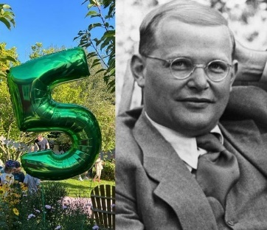

# Rev. Christian C. Tiews

[**Hamburg, Germany**](https://www.facebook.com/Hamburg-Germany-114829128532877/)

The Women’s Guild

There were 12 women present at the meeting where Vice President Jane Blesser opened the meeting with The Lord’s Prayer. Barbara Herring lead a devotion on Philippians 4:8- Think on These – Honor.

**New Business - Passion Play –**

Jane Smith will organize an outing to the Passion Play on October 24. There will be a sign-up sheet in the narthex for those who would like to attend.

**Meal November 12, –**

We will have a catered meal following our November 12th Annual Voter’s Assembly meeting. The menu will be Lasagna, salad, garlic bread and desert will be served. Lasagna & bread will be ordered from Sugar Shack and Salad and desert from members of the Women’s Guild.

**Early Slate of Officers Determined –**

Due to Barbara Herring stepping down in September as Recording Secretary, (since she is not here often). And Terri deciding to step down as President for the new year the following individuals have agreed to stand for the new positions or continue to hold their previously held positions. **Stephanie Garrett –** President **; Jane Bleser –** Vice President(continuing in this position)**;   
Vicki Garrett –** Treasurer**; Terri Herman –** Recording Secretary.

**Mission Projects –**

Barbara Herring gave a presentation of various missions we could contribute to. The Following Charities were discussed along with others. Those listed below were agreed to some with additional information requested. *Heifer International; Roofs for Tanzania; Orphan Grain Train; Lutheran Center for Religious Freedom; Flint Street; Into the Light (Support their Christmas efforts – gifts for survivors 2 at least).* This gives us 2 International missions, 2 National missions, and 2 Local missions. More information will be presented in October and the level of funding and final votes will be made at the October Mtg.

**Congregational Birthday Recognition –**

Beginning Sunday October 1, 2023, the Guild will pay for or provide a birthday cake on the First Sunday of the month for all members who will be celebrating a birthday that month.

**Next Meeting –** Tuesday October 17, 2023. Fellowship at 10:00 & Meeting at 11:00 AM

All women of Grace are invited to attend. The meetings are held the 3rd Tuesday of the month at 11:00 AM. We now share a Fellowship time before the meeting that starts at 10:00 AM.

Respectfully Submitted:

Barbara Herring, Secretary

**Sunday School**

**October 15, 2023 11:00 a.m.**

     We will begin Sunday School for our 3 little ones (Ariella, Willow and Ella) and any visitors Sunday, October 15th following fellowship and see how it goes.

     If you are willing to help by teaching, please let Sharon know as there will be times she needs to be gone.  **Thank  you!!**

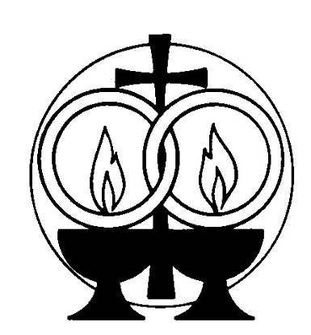

# September

# Anniversaries

Joshua & Stephanie Garrett 15



# October

Birthdays

Larry Saxton 2

Sherry Fenske 16

Becky Achord 15

Angela Saxton 20

Willow Goline 29

**Women’s Bible Study**

***“Promised Rest”***

**by Michelle Diercks**

**When:**Monday, October 23rd

at 10:30 a.m.

**Where:** Sharon’s house

             12 Appaloosa Drive

             Holiday Island, AR 72631

**ALL women from Grace are invited and welcome** – even bring a friend if you would like. If you have not already let me know you are coming, please email me or call me at: [Sheasinger1@gmail.com](mailto:Sheasinger1@gmail.com)

      918-855-6593

Passion Play

A Fall outing to those that are interested in attending The Great Passion Play on Tuesday, October 24th.

The time is 7:30. The cost will be $10.00 person. **Please** sign up on the sign-up sheet in the back of the church if you are interested in attending as a group.



**Reformation Celebration**

**The end of October**