1 Circumcision and Name of Jesus  Worship with Communion – 9:30 | 2 | 3 | 4  Men’s Fellowship – 8:30am | 5 | 6 The Epiphany | 7
8 The Baptism of Our Lord  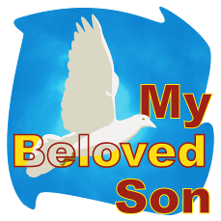  Worship with Communion – 9:30  Installation Service – 3:00pm  Reception follows | 9 | 10  Elders – 8:00am  Council – 9:00am | 11 | 12  Bible Study: 2:00pm | 13 | 14
15 2nd Sunday after the Epiphany  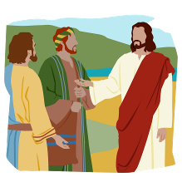  Worship with Communion – 9:30  Bible Study - 11:00am | 16 | 17  Circuit Conference  Siloam Springs  Women’s Guild  Fellowship – 10:00  Meeting – 11:00am | 18 | 19  Bible Study: 2:00pm | 20 | 21
22 3rd Sunday after the Epiphany  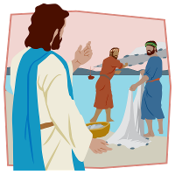  Worship with Communion – 9:30  Bible Study - 11:00am | 23 | 24 | 25 | 26  Bible Study: 2:00pm | 27 | 28
29 4th Sunday after the Epiphany  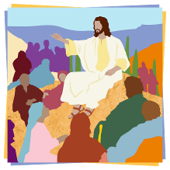  Worship with Communion – 9:30  Bible Study - 11:00am | 30 | 31
Grace Lutheran Church January 2023 Holiday Island, Arkansas
Sunday Monday Tuesday Wednesday Thursday Friday Saturday

